SPECTATOR NOTICE

Issued July 2019
SMOKE - NO JOKE

As a member Club participating in The National League we have been directed to take the strongest action available against anyone found in possession of a Flare, Smoke Bomb or any other such pyrotechnic article(s).

Spectators are warned that we and The National League apply a zero tolerance approach to anyone attempting to bring such article(s) into this Ground/Stadium.

Due to their chemical make-up, a Flare, Smoke Bomb and all such pyrotechnic article(s) can be highly toxic for some people. This can lead to serious health consequences for those with pre-existing medical conditions and may in certain circumstances cause life threatening injury or concern. Some can explode and could endanger your players or club staff.

In order to protect all who enter and participate in matches, please note we reserve the right to search your person and/or effects and we further reserve the right to pursue legal action, civil or criminal, against any person who contravenes current legislation or our Ground/Stadium regulations.

To further safeguard all who attend any event at this Ground/Stadium, we welcome the receipt of any information which will assist us to deter, apprehend/detain and where appropriate prosecute, anyone in possession of; or found discharging or being a party to the discharge of, such an article(s).

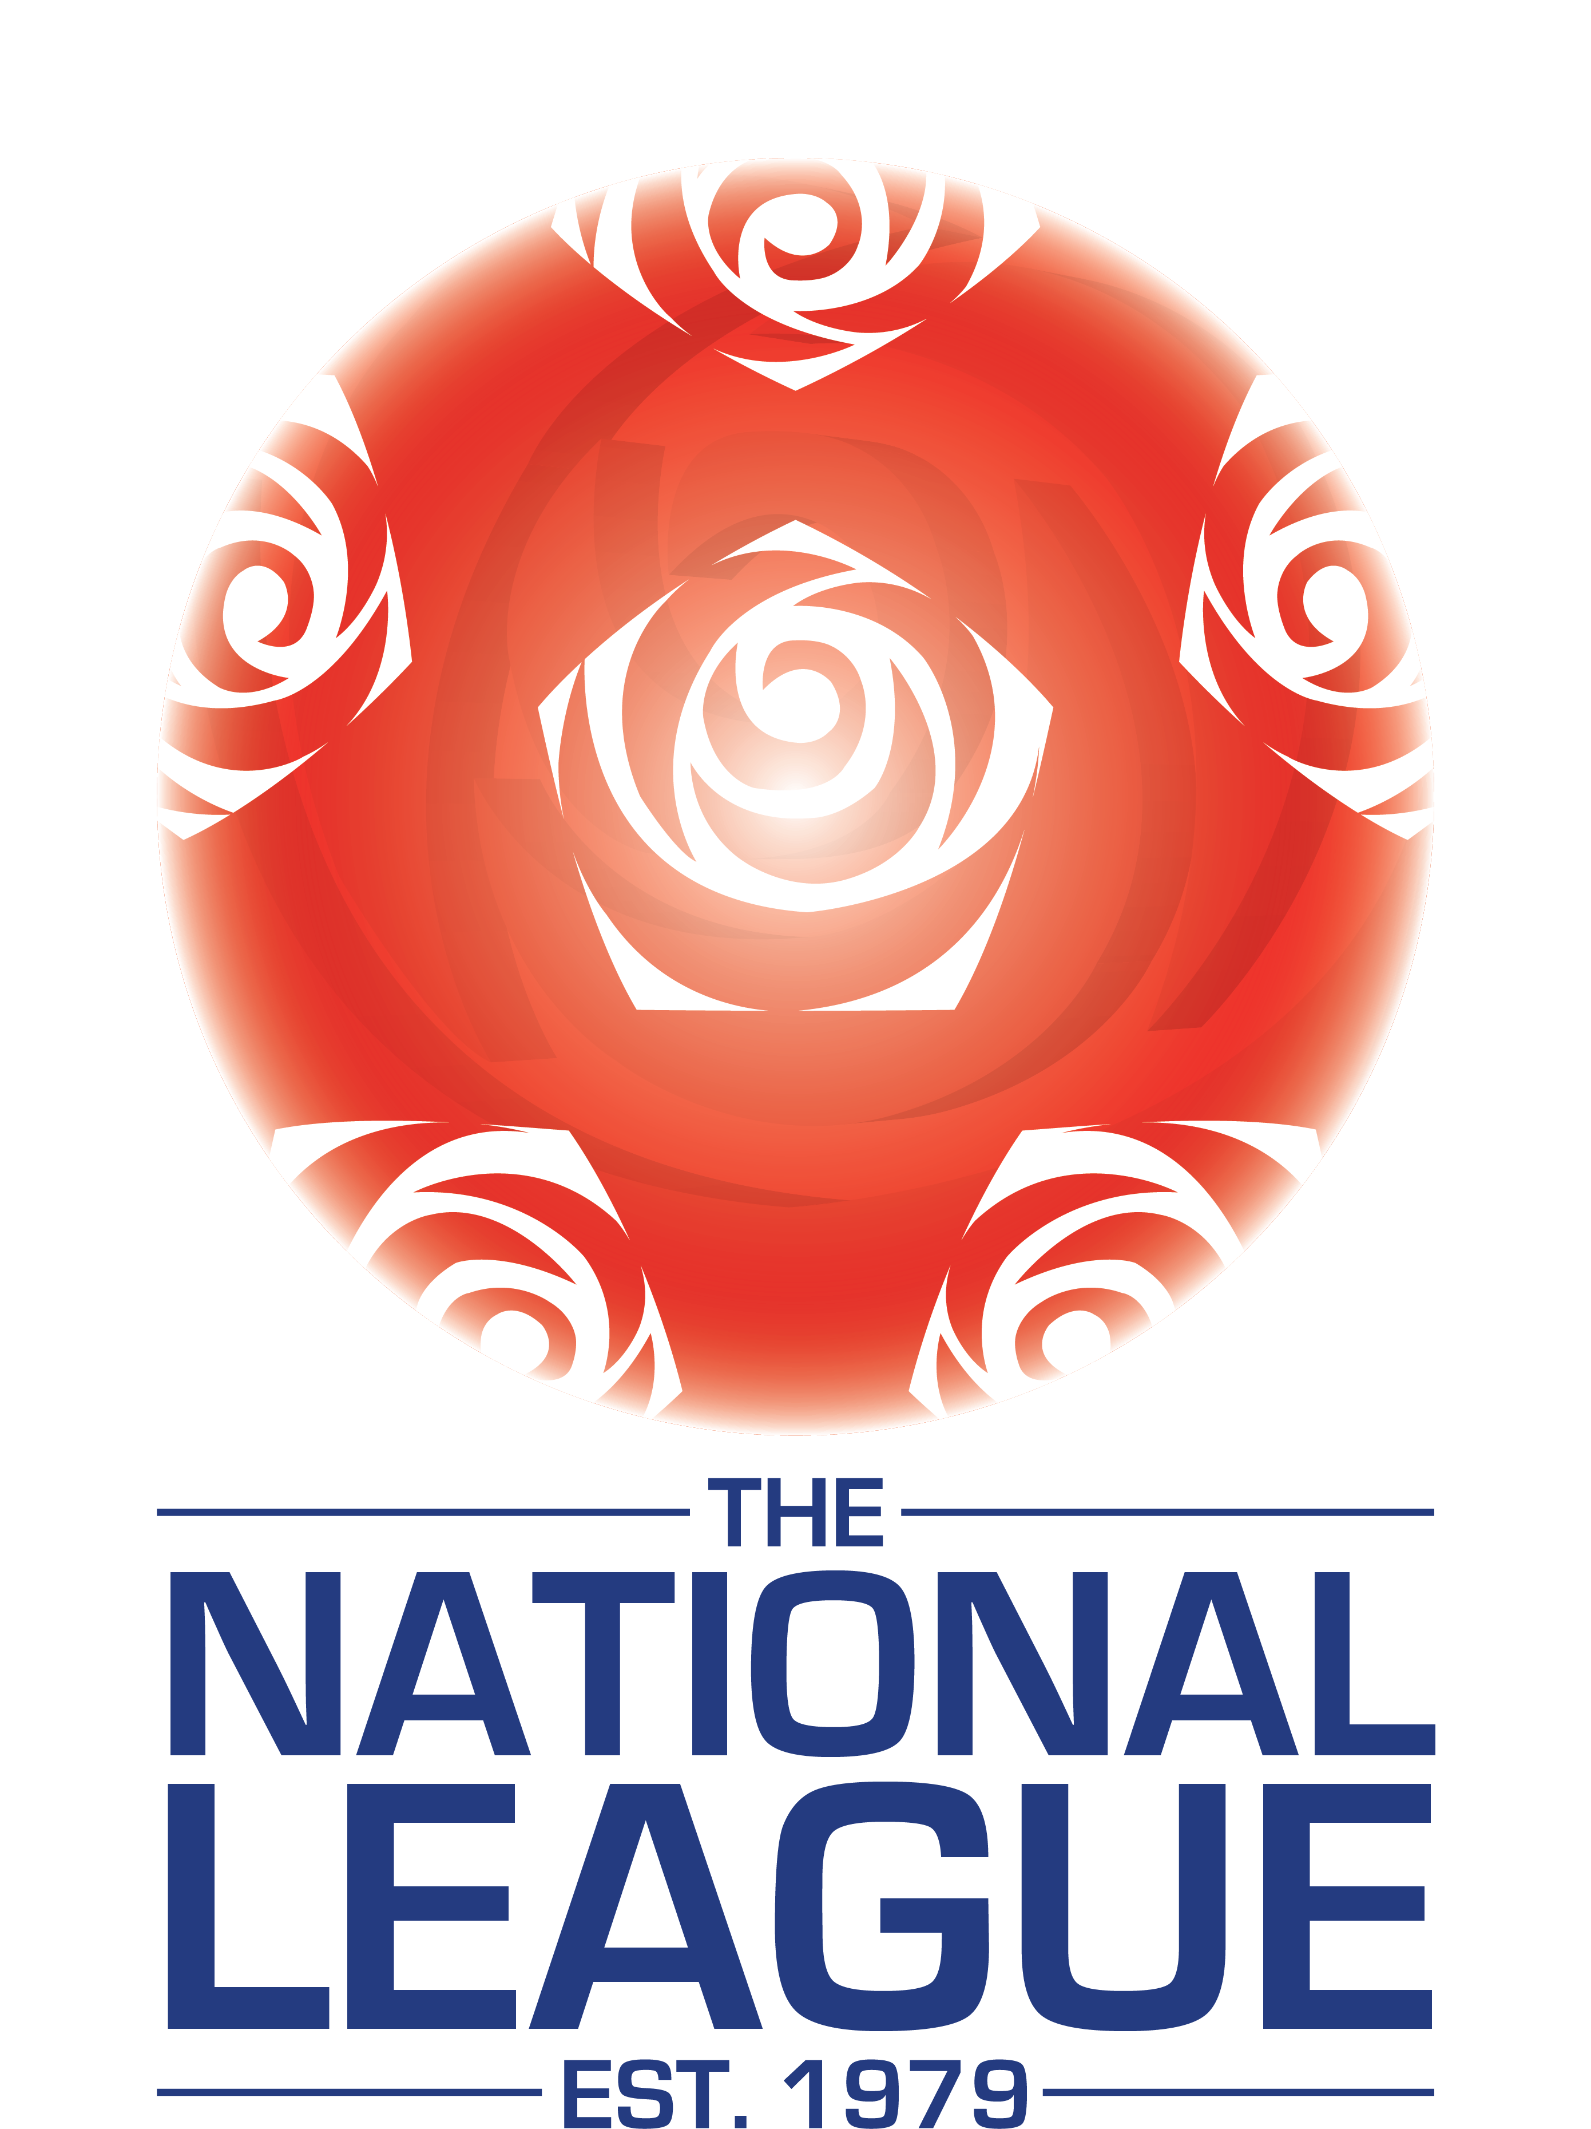 4th Floor, Waterloo House, 20 Waterloo Road, Birmingham B2 5TB

