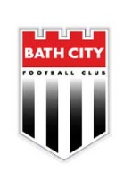
Bath City FC Shirt Sponsors Draw 2022-2023

We invite you to join the 2022/23 Bath City Football Club Sponsor’s Club and take part in our Shirt Sponsorship draw for next season after what has been an unprecedented time for us all as we now try to recover and get back to some form of normality in the coming months.
Members have the opportunity to win a number of high profile prizes through this free draw. The top prize is being named as a shirt sponsor and to have the name of your business or organisation emblazoned on the front of our first team shirts - seen by a great many people in Bath and across the South of England, on our extensive web, Facebook, YouTube and twitter channels and potentially on regional or national television
Following a season of disruption caused by Covid-19, the last draw took place in June 2021 with 60 entries with the winners, Rocketmakers, having had their name on the Bath City shirts for season 2021-2022, whilst Minuteman Press had their name on the back of the shirts with Dorothy House on the shorts.
Recent seasons have seen Bath City Football Club continue to make great strides, both on and off the field, as the new era of community led ownership continued to progress. Despite the challenges linked to the pandemic and the re-development plan hitting a few snags the Bath public and local businesses have been wonderful in the support that they have given the club whilst at the same time embracing the vision of the club as we continue to make progress in all areas.
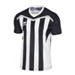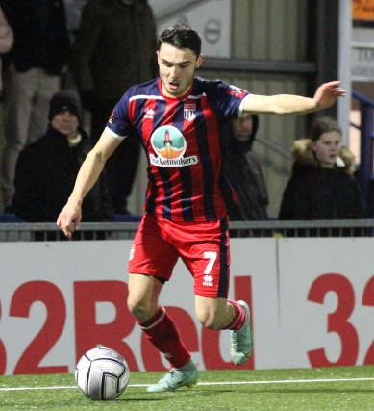
Your company name could be on next season’s shirt.
I hope that you will be interested in becoming a member of the Bath City FC Sponsors' Club for the 2022/23 Season. Membership gives you access to the free prize draw that has a number of major prizes.
It costs from just £395 plus VAT to become a member of the Sponsors' Club. Members are entitled to either one or two entries (Silver and Gold) to the Prize Draw that could see them winning the following prizes for season 2022-2023.
First prize:
- Home / away shirt sponsorship with your company or organisation’s name on the front of the first team shirts
- A full page advertisement in the Bath City match magazine.
- Two hoardings (one in the ground and one at the front of the grandstand)
- Four TR Hayes Premier Lounge season passes where you can meet some of the business partners linked to the club
- TV screen advertising, Brand Stationery, Website Promotion & PR
Second prize:
- Home/away shirt sponsorship with your brand identity on back of first team shirts
- Two TR Hayes Premier Lounge tickets for the coming season where you can meet some of the business partners linked to the club
- Website Promotion & PR
Third prize:
- Your logo on Bath City players’ back of shorts
- Two TR Hayes Premier Lounge tickets for the coming season where you can meet some of the business partners linked to the club
- Website Promotion & PR

- Fourth prize: A match sponsorship for 6 people for a League game
- Fifth prize: Advertising hoarding on the Popular side of the ground
- Sixth prize: A ball sponsorship for 6 people for a League game
- As already mentioned, no one loses, because all Sponsors' Club Members will enjoy the following benefits as part of their membership fee, regardless of whether they are successful in the Free Prize Draw:

Silver Members (£395 plus VAT) receive:
- The opportunity to make one entry into the Sponsorship Draw
- Each Silver Member’s name and corporate logo will be listed in all match day programmes for competitive home games (at a position chosen by Bath City FC in its absolute discretion) for the duration of the season.
- A season ticket for season 2022-2023 to be used for League games only.
- Free use of corporate rooms at Twerton Park, for one event, subject to availability at a time and date agreed with Bath City FC
Gold members (£790 plus VAT) receive:
- The opportunity to make two entries into the Sponsorship Draw
- Each Gold Member’s name and corporate logo will be listed in all match day programmes for competitive home games (at a position chosen by Bath City FC in its absolute discretion) for the duration of the season.
- A season ticket for season 2022-2023 to be used for League games only.
- Free use of corporate rooms at Twerton Park, for one event, subject to availability at a time and date agreed with Bath City FC
- A hospitality package for 8 people for one League fixture during season 2022-2023. A football signed by the squad for the season to be presented to the group.
Please note that only one application for Membership may be made per person or entity.
It is important that the terms and conditions included are read and that the application form is completed fully if you wish to enter the draw. Please note that the draw will take place on Wednesday 18th May at 7.30pm with the closing date being Friday 13th May (5pm).
I can also be contacted on 07786092836
Yours sincerely,
Bob Chester
(on behalf of Bath City FC)

